Testing Post-Mortem

STUDENT ID: 19025673

STUDENT NAME: ILYA KISELEV

MODULE CODE: UFCF7H-15-3

Testing Methodology

Phases

To assist my overall project testing was conducted throughout the entire process during design and development. Due to this the document is split into two sections

Testing Format

All development tests were conducted through a face-to-face demonstration during which the user is given free range to make any interactions with the app while the developer observes and takes notes.

The user is first prompted to observe and interact with the app individually after which their first impressions are logged by the developer, this process is unguided and as such the initial few feedback points are started with statements from the tester.  
The user is then fully informed of all the app’s functionalities and given some prompts to test features they may have missed, after that the user is asked some guiding questions such as what they liked about the app or what functionalities they believe are missing.

Review Format

Point out feedback and comment on it

Show changes made

Aneesa Raza (3)

Lewis Gray (4)

Remove the form to make the color scheme consistent

Lock your screen – when you are lying in bed on your side you don’t want it to turn away from your facing

Make alarm

Don’t make picnic – app icon

Patrick Robinson

1 day plan pls

Fix light mode main view list coloring

Move the list down – lewis

Remove the form greyness

Create a plan header

App icon easter egg change color

Timezone selection

For people who use it from a different country for a few days (travelling?) and want to keep their sleep schedule from home

Tutorial (move to finalised)

Vstack the list on plan view

Sam Stamp

Sam Crockett

Remove one of the add buttons

Add an alarm and allow us to select sounds

“Your app isn’t very big but you basically did everything that you did perfectly”

Development Testing

Once design testing was complete and documentation was finalised the project focus shifted to the practical coding of the app with SwiftUI. For development more testers were queried as the feedback has more potential to have a direct positive effect on the project before mistakes can be made and build upon.

There is a gap in time between the last test from the design section into the first test of the development phase as the app was missing necessary functionality for users to actually have something new to test rather than just giving feedback on the design again.

Tester 3

Feedback 3.1

This user believed that some people may benefit from having options for longer correction periods. This is not something that was considered as most people would not practically require more than 2 weeks over which to spread their schedule correction. This is a minor change that is simple to implement and test so will be brought further.

An additional 14 days were added to the correction period dropdown, due to the options appearing to the bottom off the screen they cannot be seen as intrusive so there is no drawback from this change. Additional days are seen in image 2 (right).

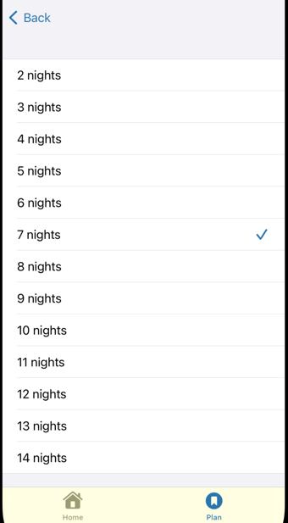 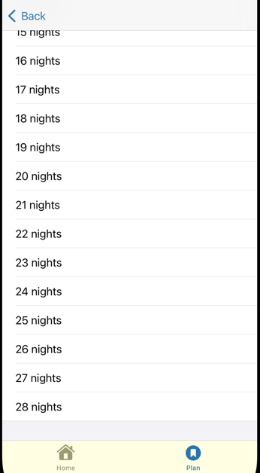

Feedback 3.2

User responded positively to the colour schemes and background choices, choices during composite design appear to have had a positive effect on the app.

Feedback 3.3

The user believed that only one button should navigate to the Create Plan View and felt the navigation bar button felt more natural. This is something that was initially disregarded but revisited in Feedback 6.2 when another user made the same comment.

Feedback 3.4

The user suggested another option to provide functionality to enter longer correction periods through text fields, however due to the changes in Feedback 3.1 this is not a necessary addition.

Tester 4

Feedback 4.1

The user stated that they did not like the colour scheme of the form Views where they would be prompted to enter details. This is a valid point as the rest of the app had a consistent colour making these views stand out in a negative way.

Functionality was implemented to match the colour of the background to the default style. This used the same code as the previous views which meant it would continue to dynamically change with light mode (left) and dark mode (right):

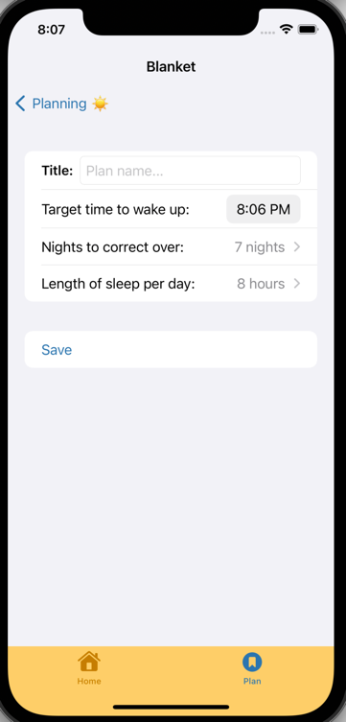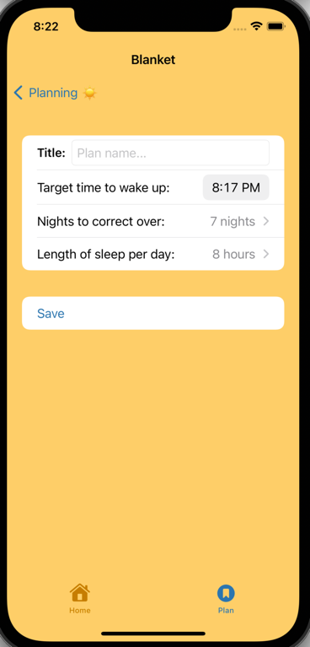 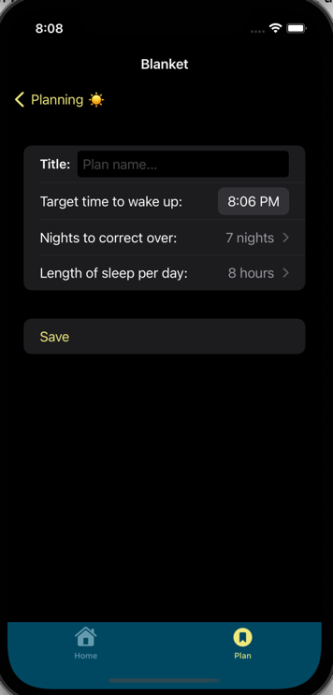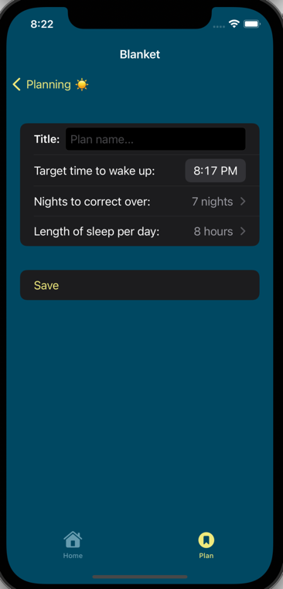

The first and third screenshots are of the previous implementation, the second and fourth are the finalised change. The tester was queried if this satisfied their feedback and they reacted with a positive verbal response.

Feedback 4.2

The user suggested that if they were to use the app in bed, they would not want the screen view to rotate. The app is not specifically designed for use in bed as it is a planner for the future, however there are no views in the app that would benefit from having a landscape view.

The app is now locked in portrait only view, the change is seen in the screenshots of the initial app in the first image and locked in the second image. The code allowed for functionality to lock specific views in portrait while leaving others to freely rotate, however this was not necessary as none of the form entry views benefited from the change.

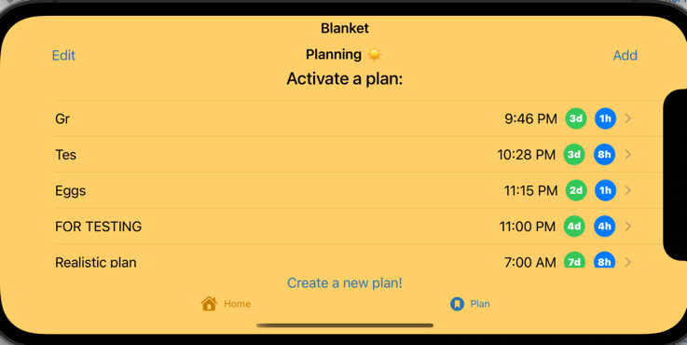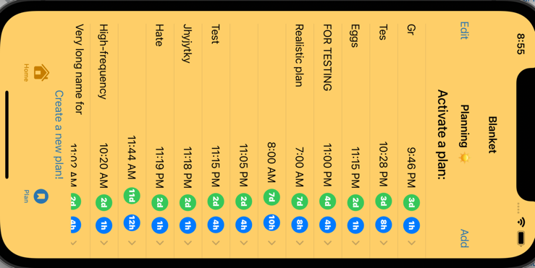

Feedback 4.3

The user suggested an alarm to be implemented into the app to make it easier for the user to automate their schedule. This is an idea that was considered during design but rejected due to the chance of a user wanting to sleep in one day from which the app would risk disturbing them.

Feedback 4.4

The logo design was scrutinised for being similar to a picnic blanket. This was meant as a joke by the tester however it was worth considering as the initial logo design was suggested by another tester who is from a different cultural background.

However after discussion with a number of students including Tester 5 it was concluded that most of them still linked the logo to a regular blanket.

Tester 5

Feedback 5.1

The user suggested that someone might want an option to select a single day for correction, however it was pointed out to them that this would essentially mean them just setting an alarm for the time they enter themselves. This point of feedback was also meant as a joke however is something to consider for future development if a user wanted to be reminded to go to bed by the app.

Feedback 5.2

The user pointed out that some of the text on the main page of the app would blend into the background due to poor text colour choice.

The issue was mitigated by advice of Tester 4 who recommended the text to be shifted down, which would mean the only background colour would be the dark trees. (Previous design left, updated design right)

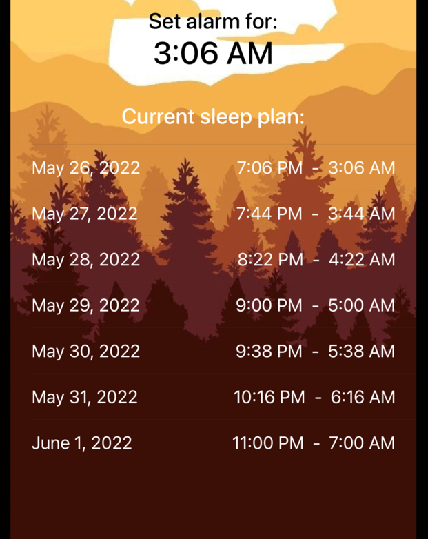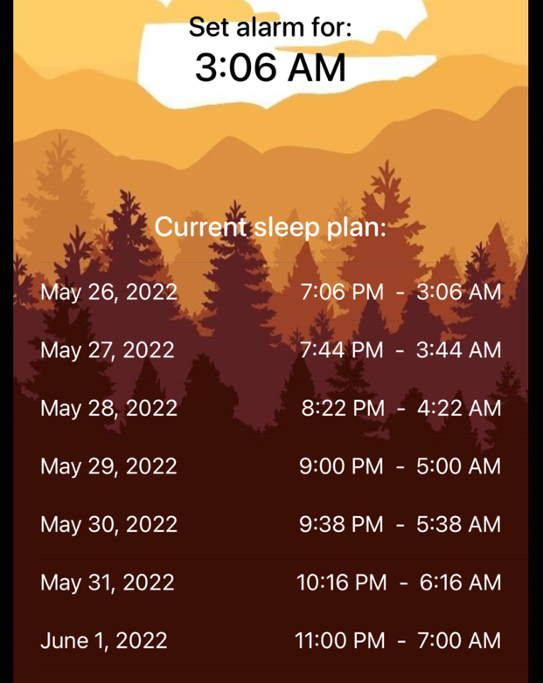

Both Testers 5 and 4 were asked if they considered this to be low enough to satisfy their feedback and both agreed that this was a more readable and should not be moved lower to avoid looking crushed. The dark mode background was also checked and remains well formatted with the new text positioning.

Feedback 5.3

This feedback is identical to 4.1 but the changes were not made until after this user tested the app because the testing was conducted over a short period of time.

Feedback 5.4

The user suggested to have a note at the top of the Create Plan View to affirm the current view for the user. This was a good idea as it has potential to improve user experience while adhering to the design pattern of the rest of the document.

A new header was added to help more confused users to follow along the app.

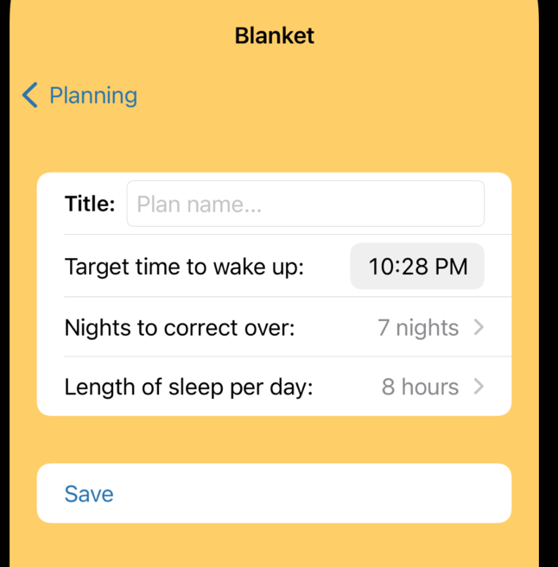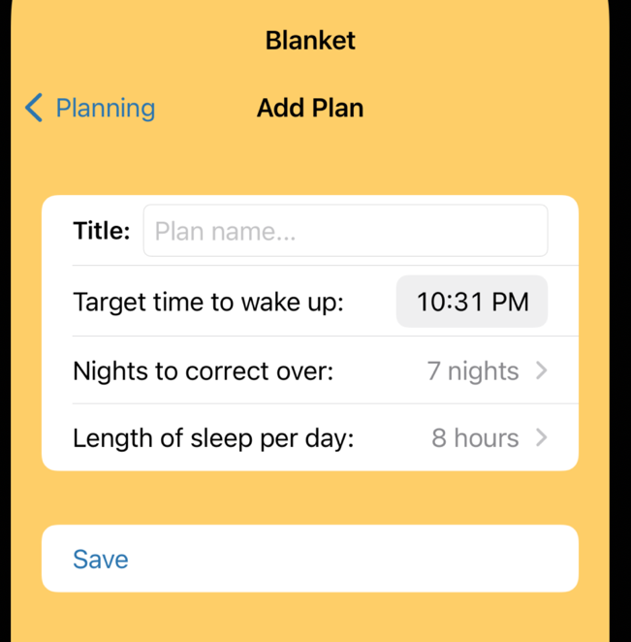

Feedback 5.5

This piece of feedback was just to make the app more friendly and engaging, the concept is to have the app icon change colour when tapped on by the user. This is a fun concept that I would implement if it was discussed at all during design but will instead have to remain as a potential future development.

Feedback 5.6

Time zone selection was another good suggestion and is elaborated on in the testing evidence. However this is a feature that would require a major overhaul of the planning code which means that due to time constrains this will have to remain as a feature for future development.

Tester 6 / Tester 7

Testers 6 and 7 were asked about the project together because it was nearing finalisation which caused their feedback to be limited.

Feedback 6.1 / Feedback 7.1

Both testers agreed that the colour and background choices for the app were very well designed, which is again attributed to the rigorous design process and feedback from testers during the design phase.

Feedback 6.2

This piece of feedback that was first mentioned in Feedback 3.3 when it was initially disregarded but when brought up by a second tester it was given more consideration. The user believed that only one button should navigate to the Create Plan View and also felt the navigation bar button felt more natural.

The bottom navigation link was removed leaving a single option to create new plans. Due to the way the program functions it is rare that a user would have to create a new plan which justifies having one button instead of two, on top of design standards frowning on having identical links on the same view.

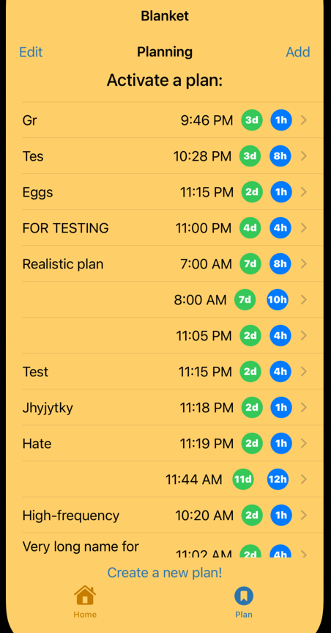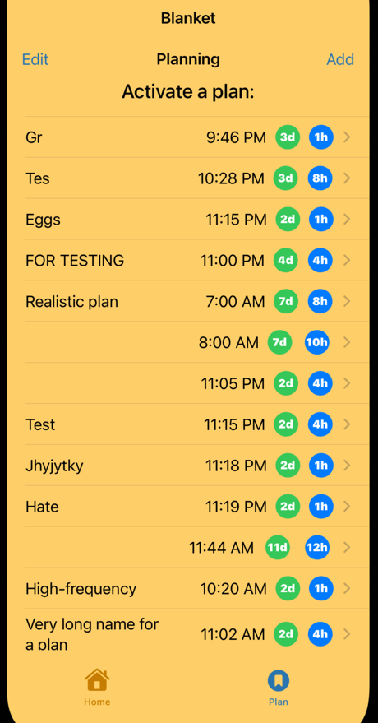

Feedback 6.3

This user also suggested an option to automatically set an alarm with the alarm time that the app plans out. They also suggested providing options of picking alarm ringtones that could be custom selected to fit the app aesthetic. As elaborated in Feedback 4.3 this idea was considered during design but due to time constraints and potential clashes with user preference this feature was pushed to potential future development.

Feedback 6.4

The user commented on how the app focuses on a specific task and performs it exceedingly well. Both testers commented on how all the factors of the design were completed “perfectly” and was only missing extra features like the aforementioned alarm clock and ringtones.

Future Developments

Different phone models